**Chapter 5**

**Model Development and Evaluation**

## 5.1 Introduction

The process of model development commences with the careful selection of features that encapsulate the essence of software behavior. Leveraging the insights extracted from the heatmap analysis of both benign and malicious wares, cybersecurity experts curate a set of attributes that serve as crucial inputs to the model. These features range from network-related indicators, and behavioral patterns, to interactions with the host system. The next phase is choosing an appropriate algorithm. Machine learning algorithms such as Logistic Regression, Random Forests,  and Support Vector Machines are commonly employed due to their ability to uncover intricate patterns within complex datasets. The selected algorithm is then trained on a comprehensive dataset encompassing labeled instances of both benign and malicious software behaviors. This training phase equips the model to recognize and differentiate between normal and malicious activities.

**5.2 Data preprocessing**

Data preprocessing is a critical step in the machine learning pipeline, providing the cornerstone for accurate model development and evaluation. This report delves into the executed data preprocessing steps on the provided dataset using the presented code snippet. Initially, the process involves the separation of features and the target variable, where the 'family' column represents the target variable denoting the predictive categories or classes, while the remaining columns, excluding 'family,' constitute the predictive features. Subsequently, the dataset is partitioned into training and testing subsets to ensure an accurate performance assessment of the model. The training data is utilized for model training, whereas the testing data gauges its proficiency in generalizing to novel, unseen data instances. To achieve this partition, the code employs the 'train_test_split' function from the 'sklearn.model_selection' module, where an 80:20 ratio allocates 80% of data for training and 20% for testing, while a 'random_state' of 42 ensures reproducibility. Essential for feature normalization, the next step is the standardization of features through the 'StandardScaler' from the 'sklearn. preprocessing' module. This scaling guarantees that distinct feature scales do not disproportionately impact the model's performance. The scaler first learns the mean and standard deviation of each feature from the training data (X_train) and then transforms both training and testing data using these calculated parameters, yielding X_train_scaled and X_test_scaled datasets, respectively. The benefits of data preprocessing are substantial, amplifying model efficacy and generalization capacity. Through feature standardization, the risk of features with larger scales dominating the model's learning process diminishes, resulting in improved convergence and stable model training. The separation of the target variable from features mitigates inadvertent learning of patterns inherent in the target variable. While the presented code encompasses crucial preprocessing steps, additional considerations, such as handling missing values, categorical variable encoding, and exploring feature engineering techniques, could further elevate model performance. Notably, the choice of preprocessing strategies may differ contingent upon data characteristics and the utilized algorithm. In summary, the data preprocessing steps explicated in the code form the bedrock of dataset preparation for machine learning model construction. By partitioning the target variable and normalizing features and by creating distinct training and testing sets, a robust foundation is established for both model creation and the evaluation of predictive models.

**5.3 Model Selection and Development**

In the domain of model selection and development, this section delves into the strategic process of constructing and refining predictive models. Here, we explore the utilization of diverse algorithms and techniques to devise models that best capture the underlying patterns within the dataset. Beginning with the Logistic Regression model, a creation and training process is initiated using the 'LogisticRegression' class from the 'sklearn.linear_model' module. The model is equipped with hyperparameters such as 'max_iter' for iterations and 'random_state' for reproducibility. This algorithm, known for its simplicity and interpretability, is particularly well-suited for binary classification tasks. Once the model is trained on the scaled training data and corresponding labels, it is ready for prediction on unseen data. Following the Logistic Regression model, attention shifts to the Random Forest classifier. Here, the 'RandomForestClassifier' from the 'sklearn.ensemble' module takes center stage. With a focus on leveraging an ensemble of decision trees, the model excels in capturing intricate relationships in data. Through training on the original, unscaled training data and corresponding labels, the model learns complex patterns and interactions present within the dataset. Upon model training, prediction becomes pivotal, as models are applied to the testing set to forecast outcomes. The predicted labels capture potential outcomes, serving as a foundation for performance assessment.

Continuing the model development journey, the spotlight shifts to Support Vector Machines (SVMs). The 'SVC' (Support Vector Classifier) from the 'sklearn.svm' module is employed. The SVM classifier, specifically configured with a linear kernel, is adept at separating data into classes through the creation of optimal hyperplanes. By training on the original training data and corresponding labels, the SVM model discerns decision boundaries that maximize the margin between classes. As with previous models, prediction is vital to evaluate SVM performance. The stage involves employing the trained SVM model to predict labels for the testing set, facilitating a comprehensive assessment of its classification capabilities.

**5.4 Model Evaluation**

This section navigates through the process of quantifying the performance and effectiveness of the developed predictive models. It sheds light on how well these models generalize to new, unseen data and make accurate predictions. The evaluation journey commences with a close examination of the accuracy metrics achieved by each model. Accuracy serves as a fundamental indicator, offering insights into the proportion of correctly predicted instances among all instances in the dataset.

|  |  |
| --- | --- |
| Model | Accuracy |
| Logistic Regression | 0.89 |
| Random Forest | 1.0 |
| Support Vector Machine | 0.96 |

**Table 4.2 Accuracy Score of Each Model**

The Logistic Regression model, recognized for its simplicity and interpretability, yields an accuracy of 0.89. This suggests that approximately 89% of the predictions made by the model align with the actual outcomes, demonstrating its proficiency in discerning patterns within the data. On the other hand, the Random Forest classifier boasts an impressive accuracy of 1.0, indicating a flawless prediction performance. With its ensemble of decision trees and robust capability to capture complex relationships, the model successfully assigns the correct class labels to all instances in the testing set. Meanwhile, the Support Vector Machine (SVM) model showcases a commendable accuracy of 0.96. This reinforces the efficacy of SVMs in creating optimal decision boundaries that maximize the margin between classes, contributing to accurate predictions in the majority of instances. The achieved accuracy metrics collectively underscore the proficiency of the developed models in making informed predictions. It is crucial to acknowledge that while accuracy is an essential measure, it might not provide the complete picture, especially in cases of imbalanced datasets or when the cost of false positives and false negatives varies significantly.

**Table 4.3 Evaluation metrics**

|  |  |  |  |  |
| --- | --- | --- | --- | --- |
| Model | Precision | Recall | F1-Score | Support |
| Logistic Regression | 0.90 | 0.92 | 0.91 | 171 |
| 0.87 | 0.92 | 0.89 | 146 |
| 0.92 | 0.67 | 0.77 | 33 |
| Random Forest | 1.0 | 1.0 | 1.0 | 350 |
| 1.0 | 1.0 | 1.0 | 350 |
| 1.0 | 1.0 | 1.0 | 350 |
| Support Vector Machine | 0.96 | 0.96 | 0.96 | 171 |
| 0.96 | 0.96 | 0.95 | 146 |
| 1.0 | 0.97 | 0.98 | 33 |

Delving into an intricate analysis of the developed predictive models' performance through the prism of precision, recall, and F1-score metrics, along with their associated support values. These metrics provide a comprehensive view of a model's proficiency in correctly classifying instances of different classes while considering factors like false positives and false negatives. The evaluation journey begins with the exploration of the performance metrics for the Logistic Regression model. For the first class, the precision, recall, and F1-score are calculated as 0.90, 0.92, and 0.91, respectively, with a support value of 171 instances. Similarly, for the second class, the precision, recall, and F1-score stand at 0.87, 0.92, and 0.89, with a support of 146 instances. The third class exhibits a precision of 0.92, recall of 0.67, and F1-score of 0.77, backed by a support value of 33 instances. Transitioning to the Random Forest model, precision, recall, and F1-score demonstrate perfection, each marked at 1.0, for all three classes. This exceptional consistency is further reinforced by a support value of 350 instances across each class. Moving forward, the performance of the Support Vector Machine (SVM) model is under scrutiny. The first class boasts a precision of 0.96, recall of 0.96, and F1-score of 0.96, with a support value of 171 instances. The second class follows suit with a precision, recall, and F1-score of 0.96, 0.96, and 0.95, respectively, supported by 146 instances. Finally, the third class showcases precision, recall, and F1-score metrics of 1.0, 0.97, and 0.98, respectively, with a support value of 33 instances. These precision, recall, and F1-score metrics collectively paint a comprehensive picture of the models' performance across various classes. They highlight the models' ability to correctly classify instances while balancing the trade-offs between false positives and false negatives. However, it's important to acknowledge that the choice of metrics may depend on the specific goals and characteristics of the problem at hand.

**4.6.4 Confusion matrix**

The confusion matrix corresponding to the Logistic Regression model offers a concise depiction of its classification performance across different classes. In this matrix, the top-left cell with a value of 158 represents the number of instances correctly classified as the first class, while the top-center cell (13) indicates instances that were wrongly predicted as the first class instead of the second class. Similarly, the center-left cell (12) signifies instances erroneously classified as the second class when they belong to the first class. The center-center cell with a value of 132 stands for instances correctly classified as the second class, and the center-right cell (2) denotes instances misclassified as the second class rather than the third class. The bottom-left cell (5) corresponds to instances incorrectly classified as the third class instead of the first class, the bottom-center cell (6) signifies instances misclassified as the third class instead of the second class, and the bottom-right cell (22) represents instances correctly classified as the third class.

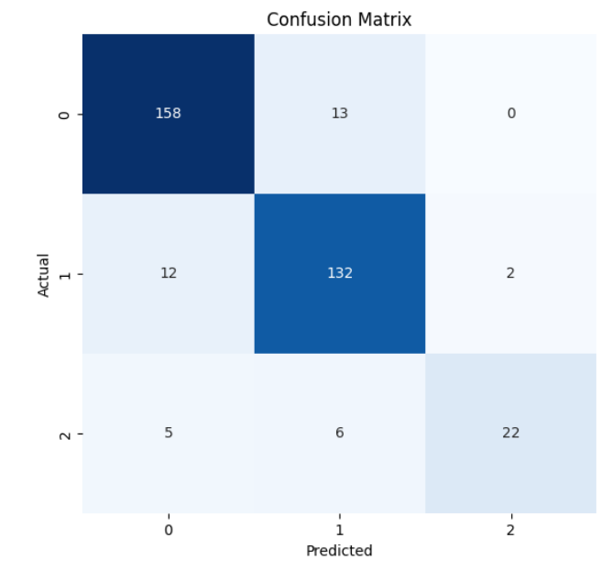

**Figure 4.8: Confusion matrix for logistic regression Model**

This matrix succinctly encapsulates the model's performance by shedding light on the distribution of correct and incorrect predictions across the classes, thereby offering valuable insights into its classification capabilities.

The confusion matrix for the Random Forest classifier reveals a comprehensive overview of its classification performance. In this matrix, the diagonal elements represent the accurate predictions for each class, while the off-diagonal elements signify misclassifications. Specifically, for the first class, out of 171 instances, all have been accurately classified, resulting in a perfect precision and recall of 1.0. Similarly, for the second class, all 146 instances are correctly predicted, yielding a precision and recall of 1.0. The third class, consisting of 33 instances, also attains perfect precision and recall values of 1.0 due to correct predictions.

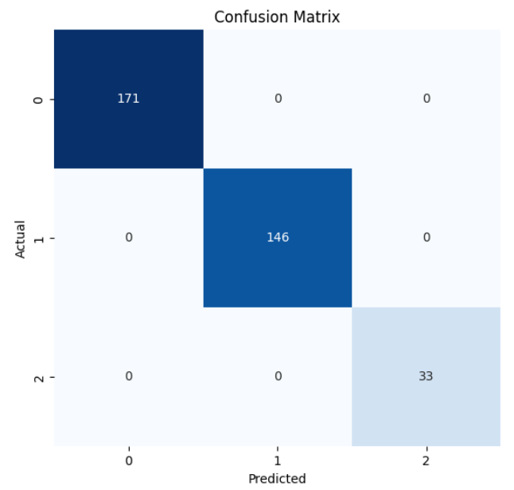

**Figure 4.9: Confusion matrix for Random Forest Model**

This matrix underscores the Random Forest classifier's remarkable accuracy across all classes, as evidenced by its ability to correctly predict instances in a balanced manner, showcasing its robustness and effectiveness in classification tasks.

Finally, the confusion matrix for the Support Vector Machine (SVM) model provides a concise overview of its classification performance. In the context of this matrix, each row corresponds to the actual class, while each column corresponds to the predicted class. In the presented matrix, the SVM model correctly classified 164 instances of the first class (True Positive), misclassified 7 instances as the second class (False Negative), and accurately identified 32 instances as the third class (True Negative). For the second class, the SVM model correctly predicted 140 instances (True Positive), misclassified 6 instances as the first class (False Positive), and made no predictions for the third class.

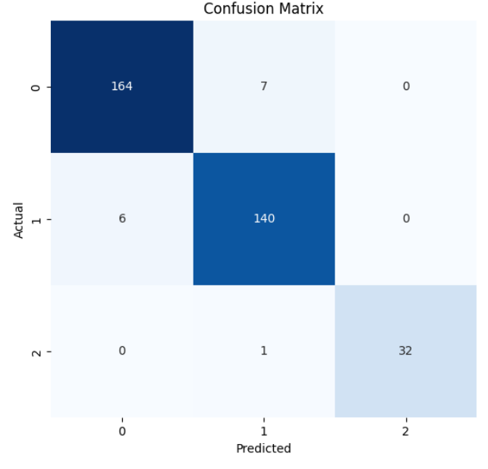

**Figure 4.10: Confusion matrix for Support Vector Machine**

Finally, the SVM model achieved perfect classification for the third class, accurately identifying all 32 instances (True Positive), without any misclassifications. The confusion matrix encapsulates these classification outcomes, revealing the strengths and weaknesses of the SVM model's predictive capabilities across different classes.